

**Mathematics Specialist Year 11**

Student name: __________________________ Teacher name: ________________

Date: Friday 24 September 2021

**Task type: Response**

**Time allowed: 40 mins**

**Number of questions: 7**

**Materials required:** Notes on two unfolded sheets of paper (to be provided by the student)

Standard items: Pens (blue/black preferred), pencils (including coloured), sharpener, correction fluid/tape, eraser, ruler, highlighters

Special items: Drawing instruments, templates and up to three calculators approved for use in the WACE examinations

**Marks available: 40 marks**

**Task weighting: 10%**

**Formula sheet provided: Yes**

**Scientific Calculator and CAS: Not Permitted**

**Note: All part questions worth more than 2 marks require working to obtain full marks.**

**Question 1 (2.2.1, 2.2.2) (6 marks)**

Given that $A$, $B$ and $C$ are $2×2$ matrices, $X= \left[\begin{aligned}2 \\ 1\end{aligned}\right]$, $Y=\left[\begin{matrix}3 & 4\end{matrix}\right]$, $Z=\left[\begin{matrix}3 & -1 \\ 0 & 2\end{matrix}\right]$ and $I$ is the $2×2$ identity matrix, find the following where possible

1. $XY$ (1 mark)
2. $YX$ (1 mark)
3. Matrix $W$ given that $3Z-W=I$ (2 marks)
4. An expression for matrix $V$ in terms of other matrices given that $V-ABV=C$ (2 marks)

**Question 2 (2.2.3, 2.2.11) (5 marks)**

1. For what values of a is the matrix $\left[\begin{matrix}a & 5 \\ 3 & a\end{matrix}\right]$ singular? (2 marks)
2. Use matrices to find the point of intersection of the lines given by the equations

$3x+y=2$ and $5x+2y=1$. (3 marks)

**Question 3 (2.1.4) (5 marks)**

Using the same scale, sketch the graphs of $y=\sin\left(2x\right)$ and $y=\operatorname{cosec}\left(2x+π\right)$ on the grid below for $0≤x≤ 2π$

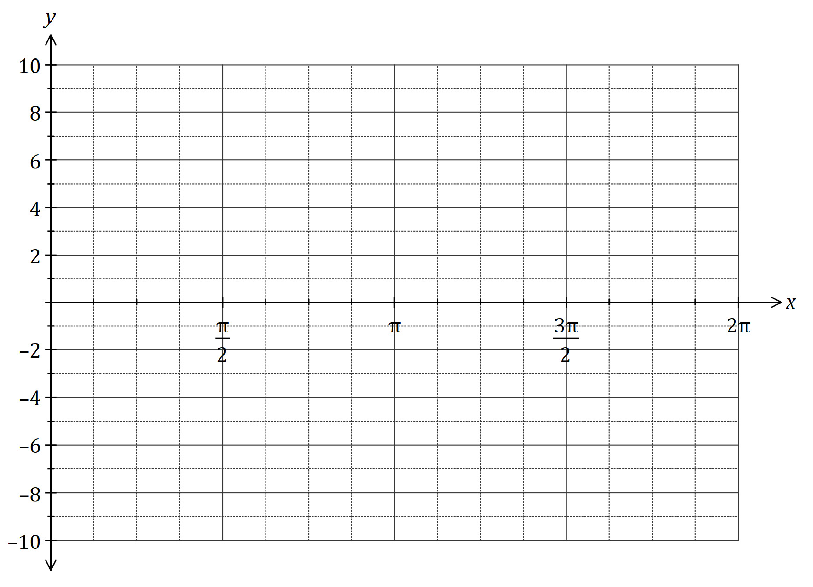

**Question 4 (2.1.5, 2.1.6, 2.1.8) (5 marks)**

Prove the identity below

$$\frac{1-sin⁡(2θ)}{\sin{θ}-cosθ}=sinθ-cosθ$$

**Question 5 (2.2.5, 2.2.7, 2.2.10) (5 marks)**

1. Find the matrices that produce each of the transformations described below
2. A reflection in the line $y=x$ (1 mark)
3. A rotation clockwise about the origin by $90°$ (2 mark)
4. Find and describe a single transformation matrix T that is a result of a reflection in the line $y=x$ followed by a $90°$ clockwise rotation about the origin. (2 marks)

**Question 6 (2.2.6, 2.2.9) (9 marks)**

1. Find the matrix of the linear transformation such that $(1,2)→(12,7)$ and $(-3,1)→(-1,0)$ (4 marks)
2. The matrix $\left[\begin{matrix}t & t \\ 1 & t\end{matrix}\right]$ maps the unit square into a parallelogram of area 2 square units. Find the possible value(s) of $t$ (5 marks)

**Question 7 (2.1.7) (5 marks)**

Find the general solution of $3cos\left(x\right)- \sqrt{3} sin\left(x\right)=3$

Additional working space Question ________

Additional working space Question ________

Additional working space Question ________